**Software Design Document**

**Intelli Shop – AI Powered Multi Modal Product Discovery**



**Submitted by**

**Noreen Safdar (F22BINFT1M01156)**

**7th (3M)**

**Submitted to**

**Dr. Mustafa Hameed**

**Department of Information Technology**

**Faculty of Computing**

**The Islamia University of Bahawalpur**

**Summery**

This Software Design Document (SDD) presents a detailed design and architectural overview of **Intelli Shop – AI-Powered Multi-Modal Product Discovery Chatbot**, developed as a Final Year Project for the Department of Information Technology. The primary goal of Intelli Shop is to address common challenges faced by users during online electronics shopping, such as information overload, lack of personalization, and difficulty in comparing products across brands.

Intelli Shop leverages modern Artificial Intelligence techniques including **image recognition**, **natural language processing**, and **machine learning–based recommendation systems** to provide an intelligent and interactive shopping assistant. Users can interact with the system through text-based queries or by uploading images of products, enabling a multi-modal experience. The system intelligently identifies products, understands user intent, and provides personalized recommendations based on budget, usage requirements, and preferences.

The system architecture follows a **modular MVC-based client–server design**, ensuring scalability, maintainability, and security. Separate layers are used for presentation, business logic, data management, and AI services. A hybrid database approach is adopted, where structured user-related data is stored in a relational database, while flexible product specifications are stored in a NoSQL database. Additionally, a vector database is used to support similarity search and intelligent matching.

This document thoroughly explains the **application architecture**, including frontend, backend controllers, external APIs, and coding conventions. It also describes the **data model schema**, detailing entities, attributes, and relationships required to support system functionality. Furthermore, the **user interface design** section explains the design philosophy, screen layouts, controls, and input constraints to ensure a user-friendly and accessible experience.

Overall, this SDD serves as a comprehensive blueprint for implementing Intelli Shop and demonstrates the application of software engineering principles, system design methodologies, and AI integration to solve a real-world problem in the domain of e-commerce.

## **Table of Content**

Table of Content ............................................................................................................................ 3

1. Application Architecture .............................................................................................................. 4  
   1.1. MVC Architecture Overview .................................................................................................. 4  
    Figure 1.1: MVC Architecture Diagram .............................................................................. 5  
   1.2. Models .................................................................................................................................. 5  
    Figure 1.2: Data Models Class Diagram .............................................................................. 6  
   1.3. Views .................................................................................................................................... 6  
   1.4. Controllers ............................................................................................................................ 7  
    Authentication Controller ............................................................................................. 7  
    Figure 1.3: Authentication Controller Sequence Diagram .............................................. 8  
    User Profile Controller .................................................................................................. 8  
    Figure 1.4: User Profile Controller Sequence Diagram .................................................. 9  
    Product Controller ........................................................................................................ 9  
    Figure 1.5: Product Controller Workflow Diagram ...................................................... 10  
    Recommendation Controller ...................................................................................... 10  
    Figure 1.6: Recommendation Engine Flow Diagram .................................................. 11  
    Comparison Controller ............................................................................................... 11  
    Figure 1.7: Product Comparison Sequence Diagram .................................................. 12  
    Chatbot Controller ...................................................................................................... 12  
    Figure 1.8: Chatbot Interaction Sequence Diagram ................................................... 13  
    Admin Controller ........................................................................................................ 13  
    Figure 1.9: Admin Module Architecture Diagram ....................................................... 14  
   1.5. APIs ..................................................................................................................................... 14  
   1.6. External APIs and Libraries .................................................................................................. 15  
   1.7. Coding Conventions ............................................................................................................. 16
2. Data Model Schema .................................................................................................................. 17  
    Figure 2.1: Entity Relationship (ER) Diagram .............................................................. 18
3. User Interface ............................................................................................................................ 20  
    Figure 3.1: Intelli Shop Home & Chat Screen UI ............................................................ 21  
    Figure 3.2: Product Comparison Screen UI ................................................................. 22  
    Figure 3.3: User Dashboard Screen UI ......................................................................... 23

## **1. Application Architecture**

Intelli Shop follows the **Model-View-Controller (MVC)** architectural pattern to ensure modularity, scalability, and ease of maintenance. The application is divided into three major layers:

* **Model:** Handles data logic and database interaction
* **View:** Manages user interface and presentation
* **Controller:** Processes user requests and coordinates between Model and View

The backend exposes RESTful APIs that are consumed by web and mobile clients.

### **1.1 MVC Architecture Overview**

The MVC architecture ensures separation of concerns:

* Users interact with the **View** (web/mobile UI)
* Requests are forwarded to the **Controller**
* Controllers process logic using **Models**
* Responses are sent back to the View

**Figure:**

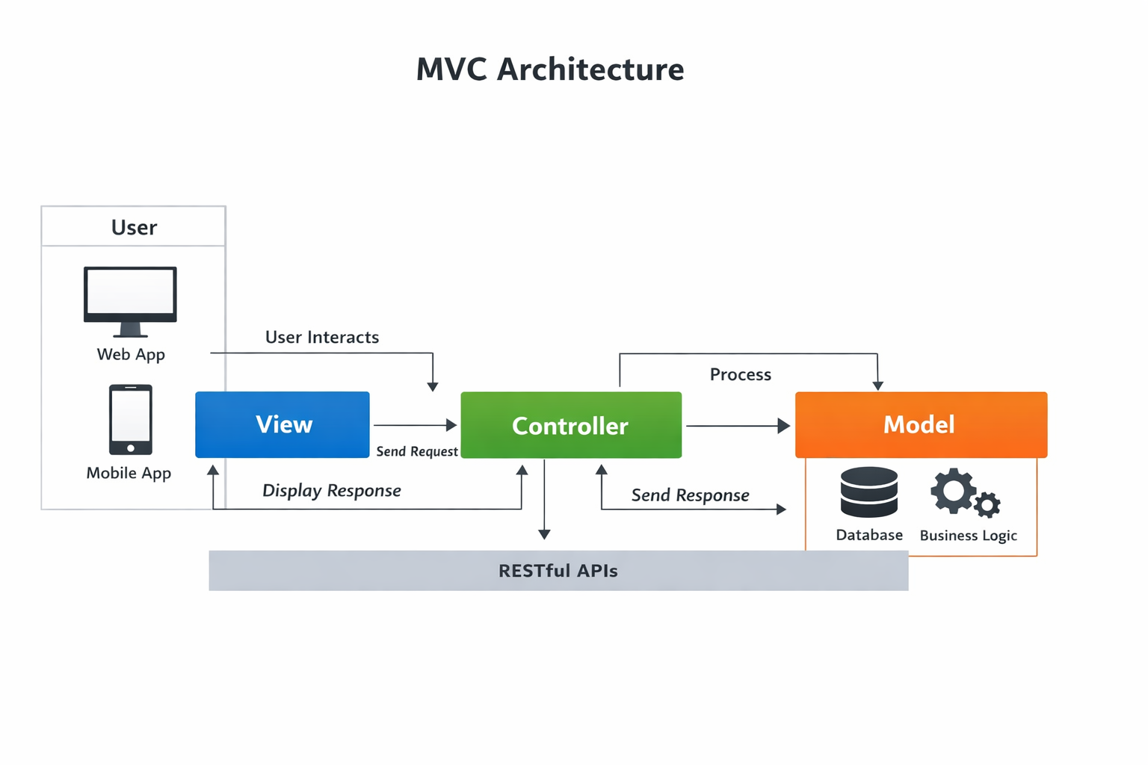

### **1.2 Models**

### The Model layer represents the business entities and database interaction logic. Major models include:

* User
* Product
* Brand
* Recommendation
* Comparison
* Watchlist
* Chat History
* Budget

**Figure:**

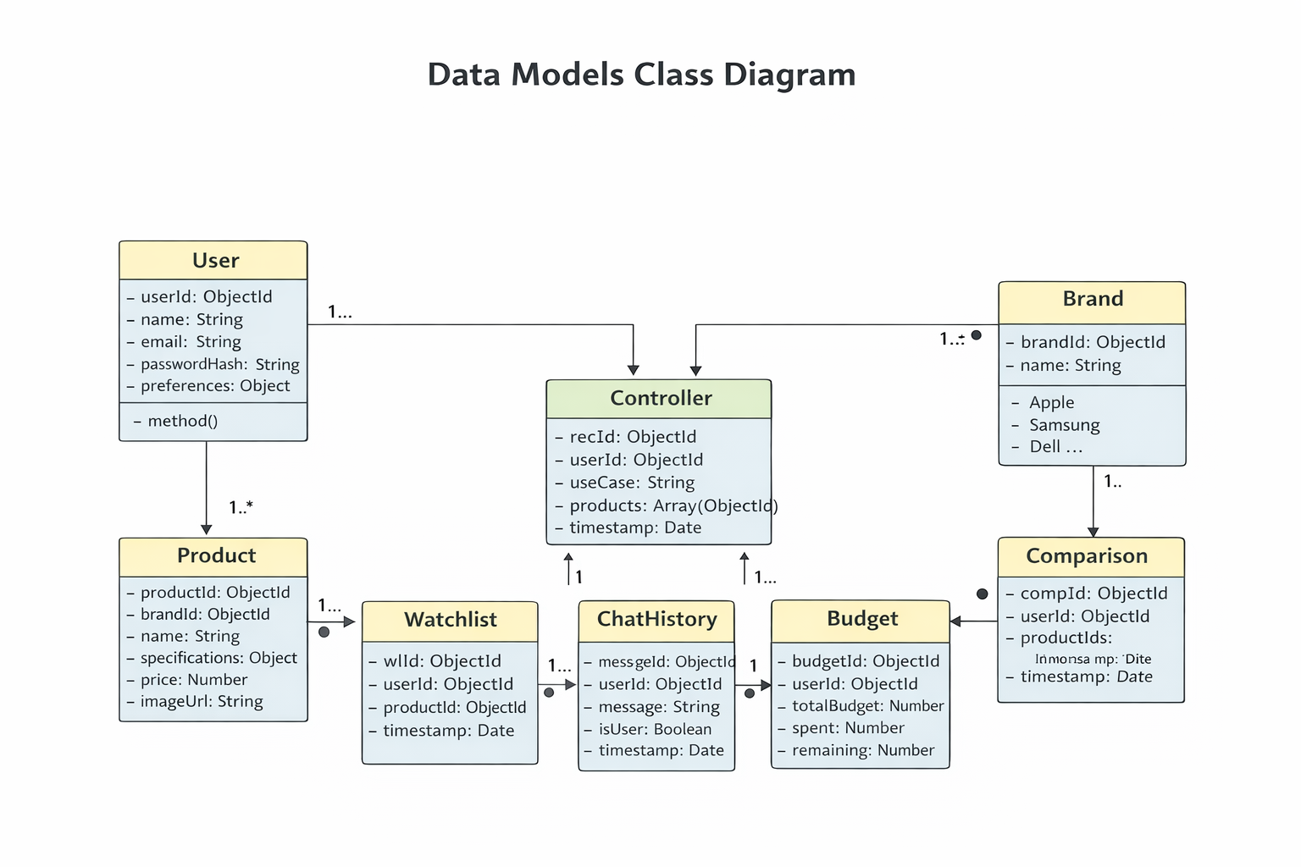

### **1.3 Views**

Views are responsible for presenting data to users. IntelliShop supports:

* Web Interface: (React.js / Next.js)
* Mobile Interface: (React Native / Flutter)
* Personalized Dashboard**:** A visual interface for tracking watchlists and budget history.

Views consume APIs and render dynamic content such as product cards, comparison tables, dashboards, and chat interfaces.

### **1.4 Controllers**

Controllers handle application logic and API request processing.

#### **Authentication Controller**

Functions:

* User registration
* User login
* JWT token generation
* Password recovery

**Figure:**

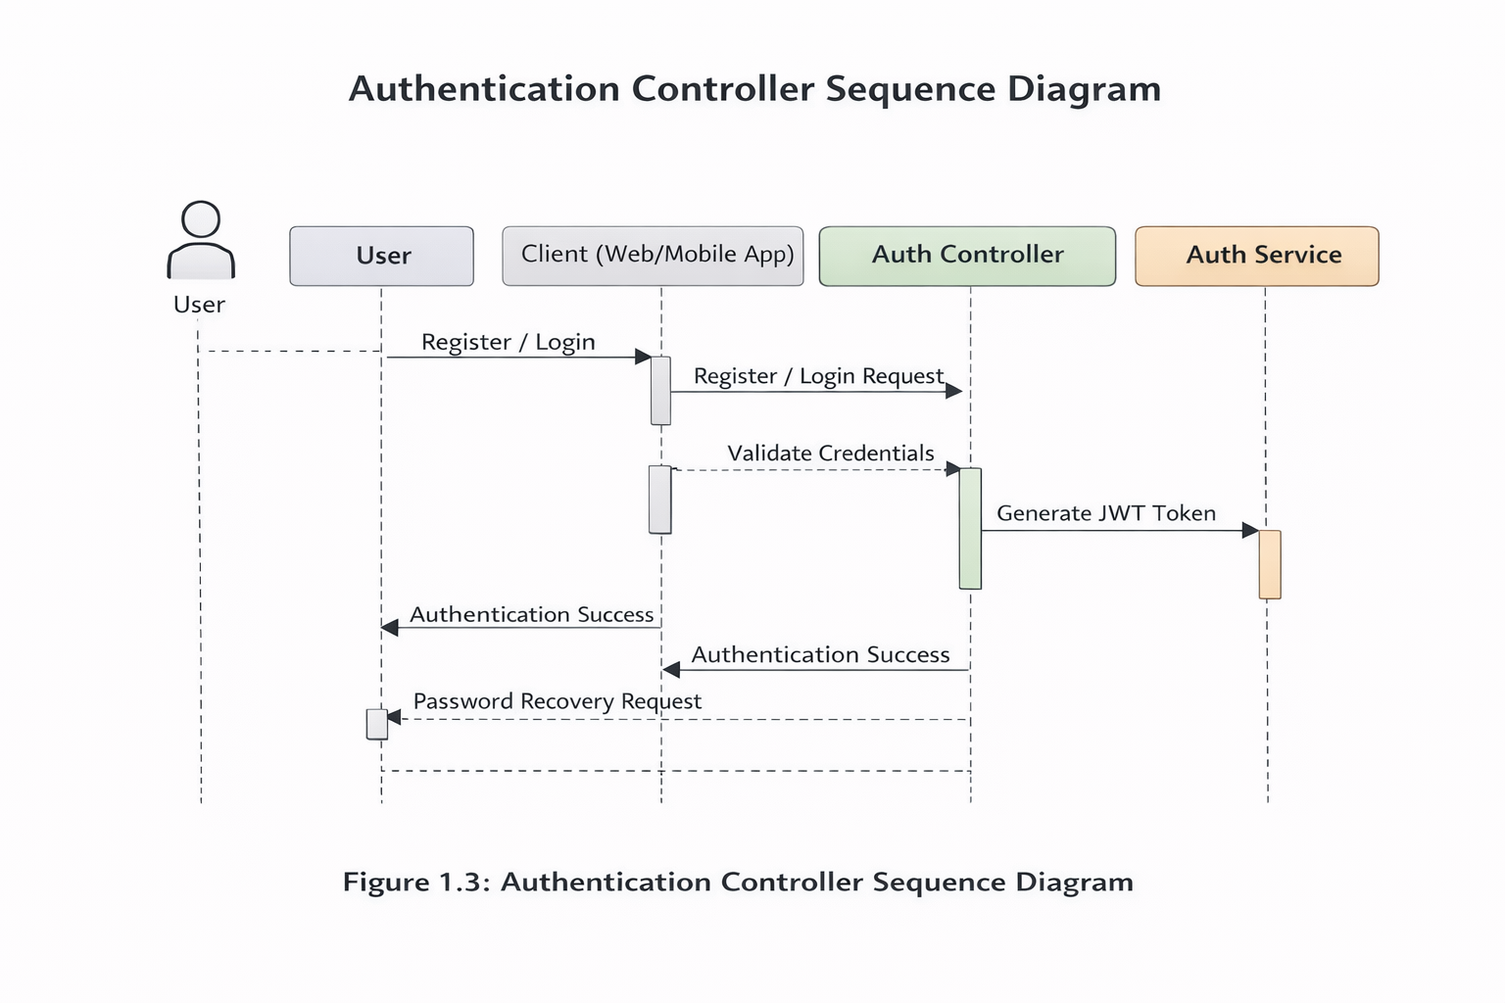

#### **Product Discovery Controller**

Handles multi-modal inputs to find products.

* **Text Search:** Processes natural language queries via NLP.
* **Image Search:** Integrates TensorFlow/PyTorch to recognize products from uploaded photos.

Figure:

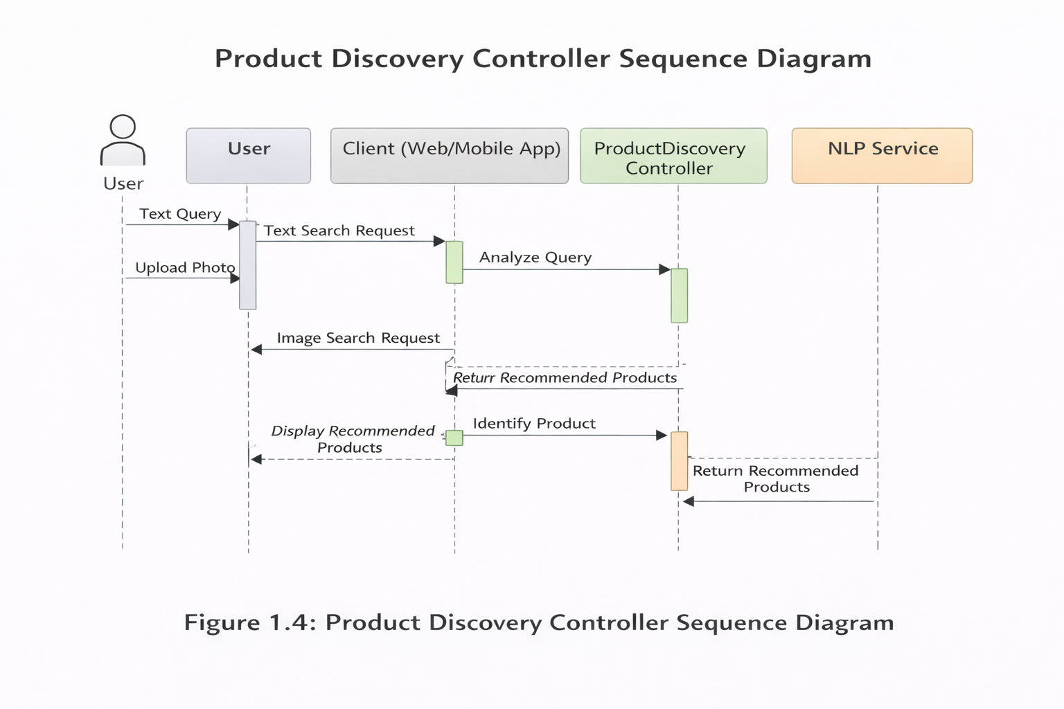

#### **User Profile Controller**

Functions:

* Create and update user profile
* Manage preferences
* Retrieve user dashboard data

Figure:

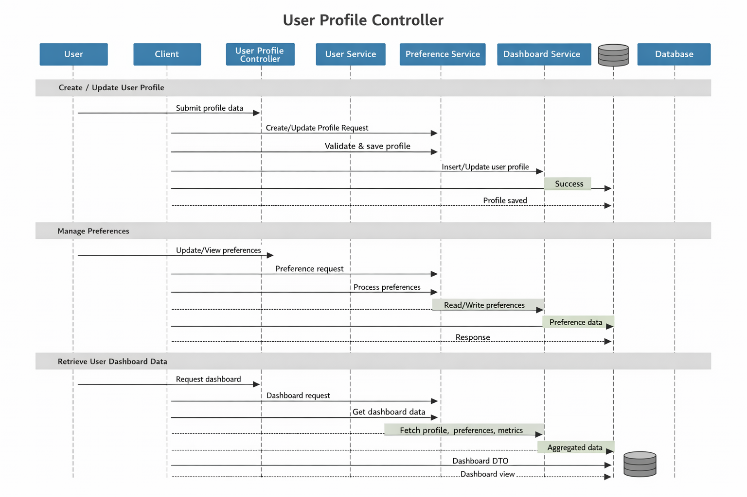

#### **Product Controller**

Functions:

* Search products
* Filter and sort products
* Fetch product details
* Handle image-based product recognition

Figure:

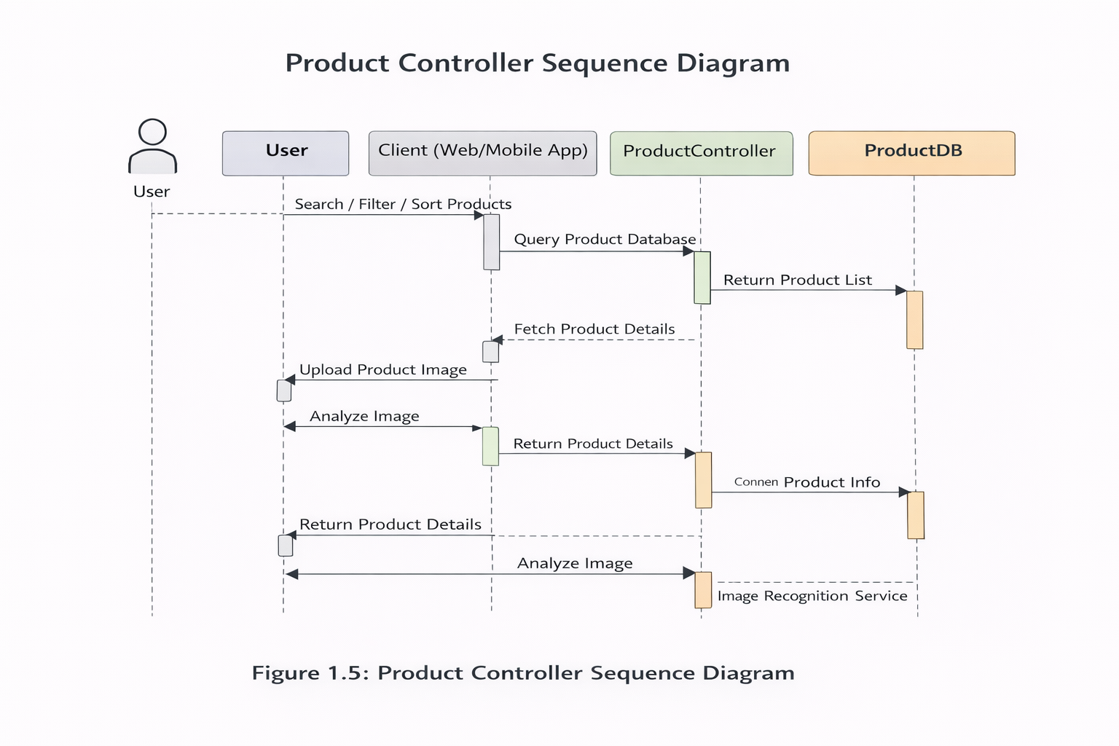

#### **Recommendation Controller**

Functions:

* Analyze user preferences
* Generate personalized recommendations
* Budget-based product suggestions

Figure:

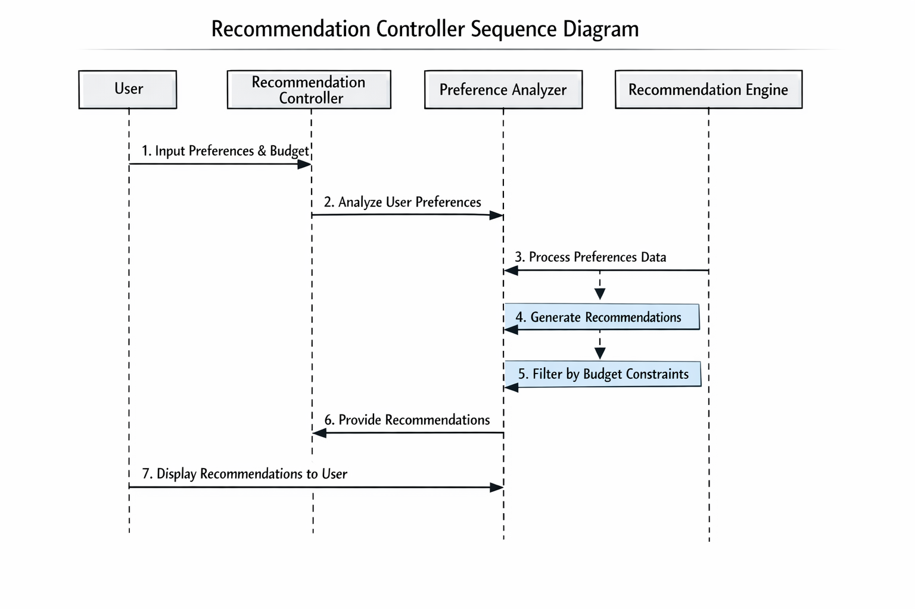

#### **Comparison Controller**

Functions:

* Compare up to four products
* Generate AI-based comparison insights
* Export comparison reports (PDF)

Figure:



#### **Chatbot Controller**

Functions:

* Handle user queries
* Maintain conversational context
* Integrate NLP responses

Figure:



#### **Admin Controller**

Functions:

* Manage product catalog
* Update prices and specifications
* Manage users

Figure:

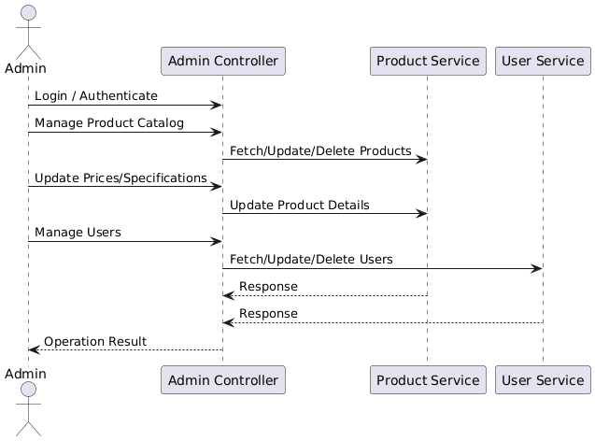

### **1.5 APIs**

**A list of key internal API endpoints for frontend-backend communication.**

|  |  |  |  |  |
| --- | --- | --- | --- | --- |
| **Endpoint** | **Method** | **Description** | **Parameters** | **Response** |
| **/api/auth/login** | POST | User login | **email**, **password** | **{user, token}** |
| **/api/products/search** | GET | Text-based search | **q** (query string) | **[Product]** |
| **/api/products/search-by-image** | POST | Image-based search | **image** (file) | **{brand, model, products}** |
| **/api/recommendations** | GET | Get recommendations | (uses user context) | **[Product]** |
| **/api/compare** | POST | Compare products | **productIds: []** | **{comparisonData}** |
| **/api/dashboard/watchlist** | GET | Get watchlist | - | **[Product]** |
| **/api/dashboard/watchlist** | POST | Add to watchlist | **productId** | **{success}** |

### **1.6 External APIs and Libraries**

* OpenAI / Claude API for chatbot NLP
* Google Vision API / TensorFlow for image recognition
* Pinecone / Chroma for vector similarity search
* JWT for authentication
* bcrypt for password hashing

### **1.7 Coding Conventions**

* Follows REST API naming standards
* CamelCase for variables and functions
* MVC folder structure
* Proper error handling and logging
* Modular and reusable components

## **2. Data Model Schema**

The data layer will be split across two databases as proposed.

* **MongoDB:** Will store unstructured product data (specifications, images, prices) due to its flexibility.
* **PostgreSQL:** Will store structured relational data concerning users, their sessions, and preferences.

**Key Data Models:**

1. **User Model (PostgreSQL):**
   1. **userId** (UUID, Primary Key)
   2. **email** (String, Unique)
   3. **passwordHash** (String)
   4. **firstName** (String)
   5. **lastName** (String)
   6. **preferences** (JSONB - e.g., **{useCase: "gaming", priority: "performance", budget: 150000}**)
   7. **createdAt** (Timestamp)
   8. **updatedAt** (Timestamp)
2. **Product Model (MongoDB):**
   1. **_id** (ObjectId)
   2. **name** (String)
   3. **brand** (String)
   4. **category** (String: "smartphone", "laptop")
   5. **specifications** (Embedded Document - key-value pairs for RAM, storage, CPU, etc.)
   6. **price** (Number)
   7. **imageUrls** (Array of Strings)
   8. **sourceUrl** (String - link to e-commerce site)
   9. **featureVector** (Array - stored in Vector DB for similarity search)
3. **UserSession Model (PostgreSQL):**
   1. **sessionId** (UUID, Primary Key)
   2. **userId** (Foreign Key to User)
   3. **conversationHistory** (JSONB array to store chat history for context)
   4. **expiresAt** (Timestamp)
4. **Watchlist Model (PostgreSQL):**
   1. **watchlistId** (UUID, Primary Key)
   2. **userId** (Foreign Key to User)
   3. **productId** (String, reference to MongoDB Product **_id**)
   4. **addedOn** (Timestamp)

**Figure:**

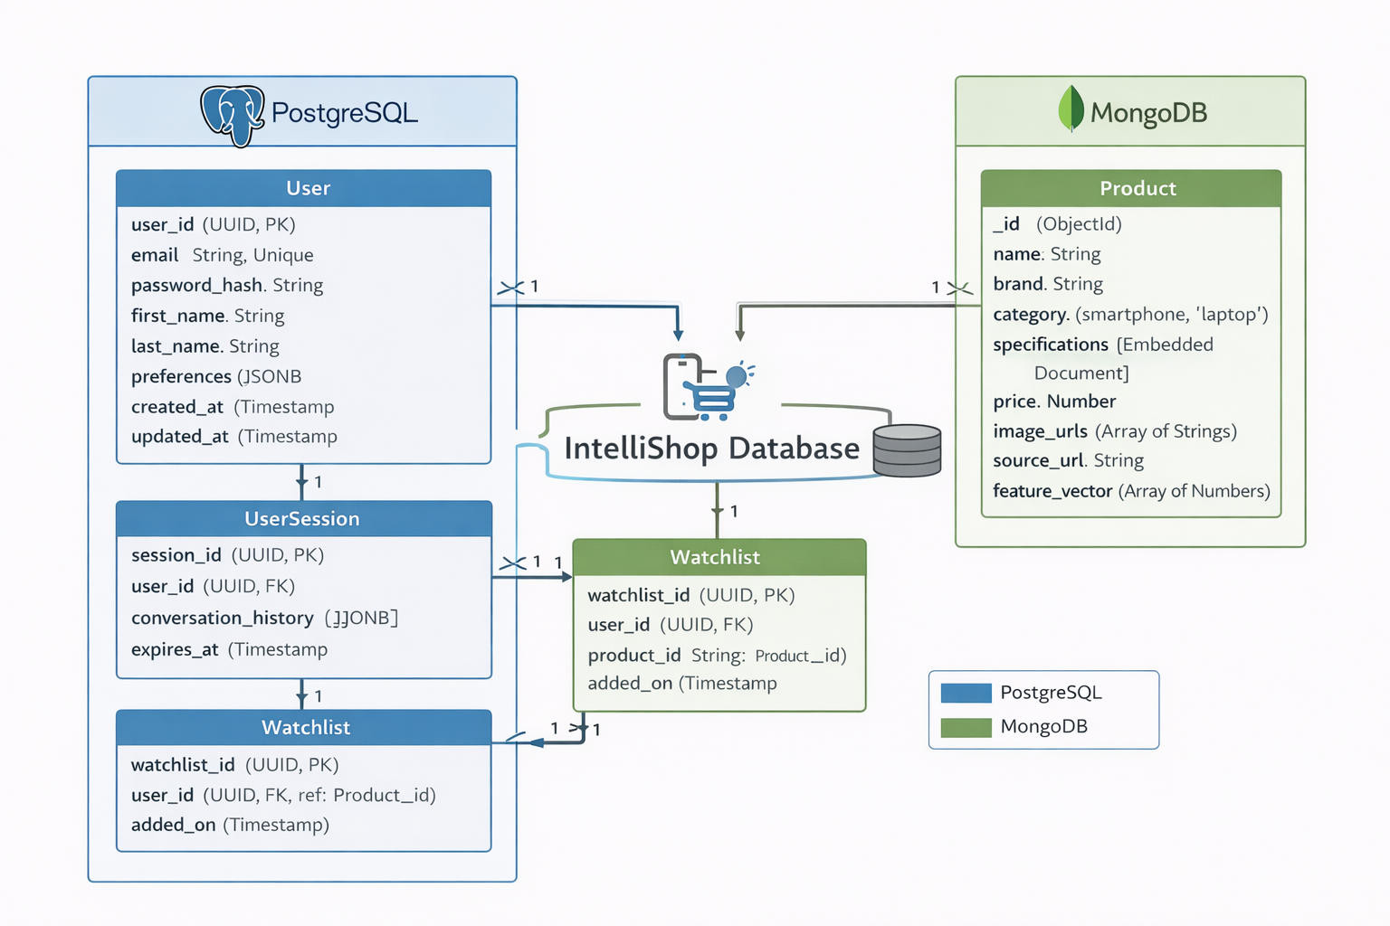

## **3. User Interface**

### **Design Philosophy**

* Clean and minimal UI
* Responsive design for mobile and web
* Tailwind CSS / Material UI components
* English and Urdu language support

### **Major Screens**

* Login & Registration Screen

Figure:

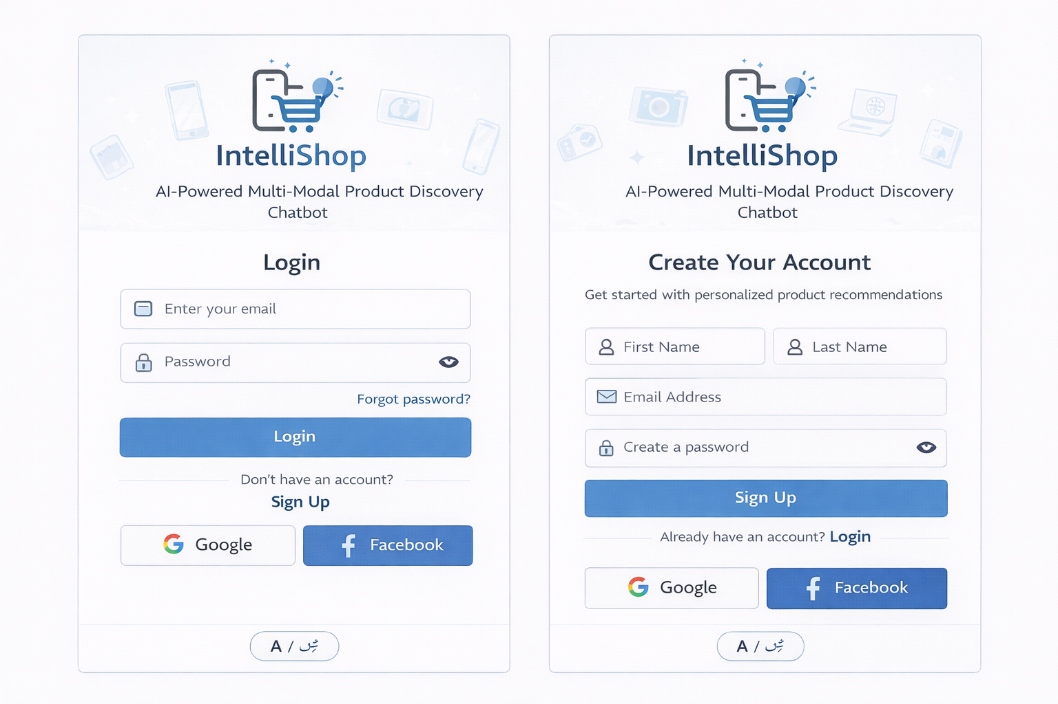

* **Home / Chat Interface**

**Figure:**

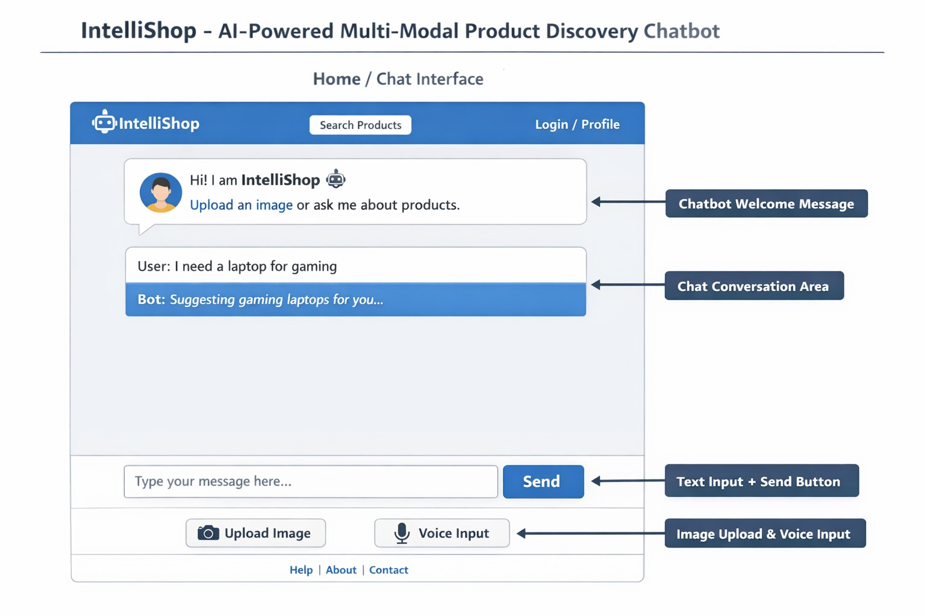

* **Product Search Results**

**Figure:**

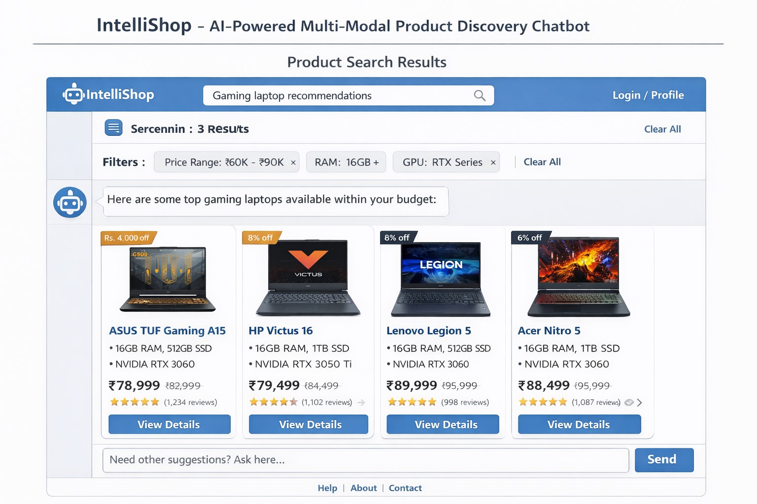

* **Product Detail Page**

**Figure:**

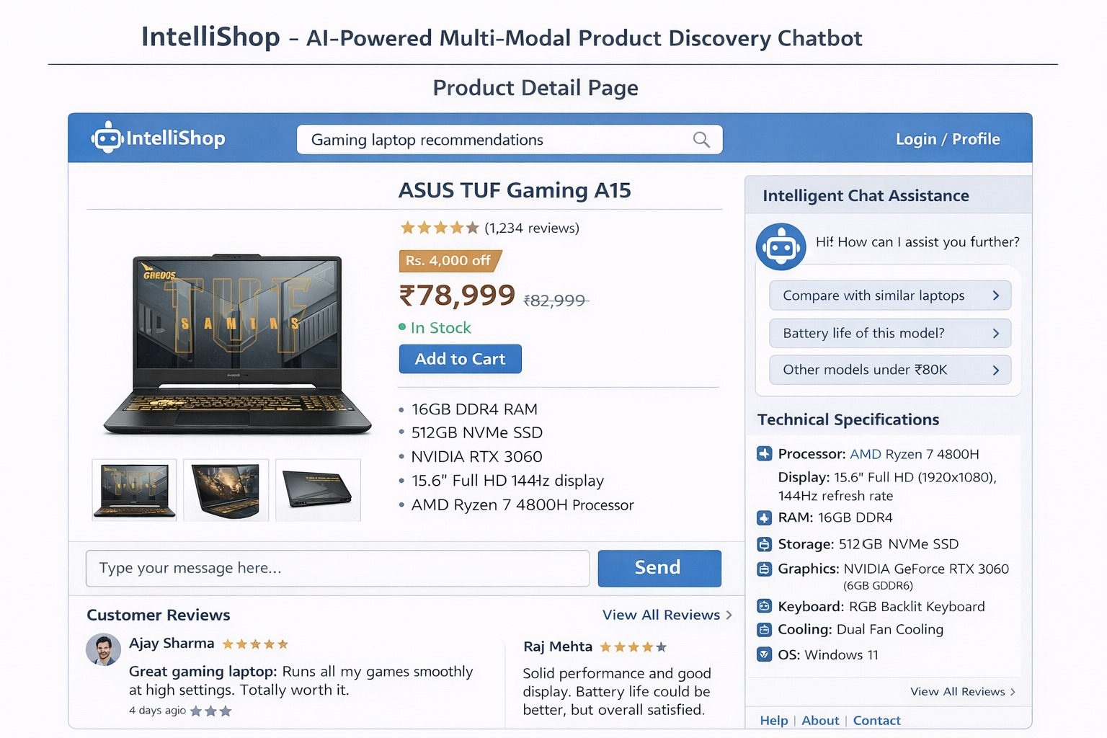

* **Comparison Page**

**Figure:**

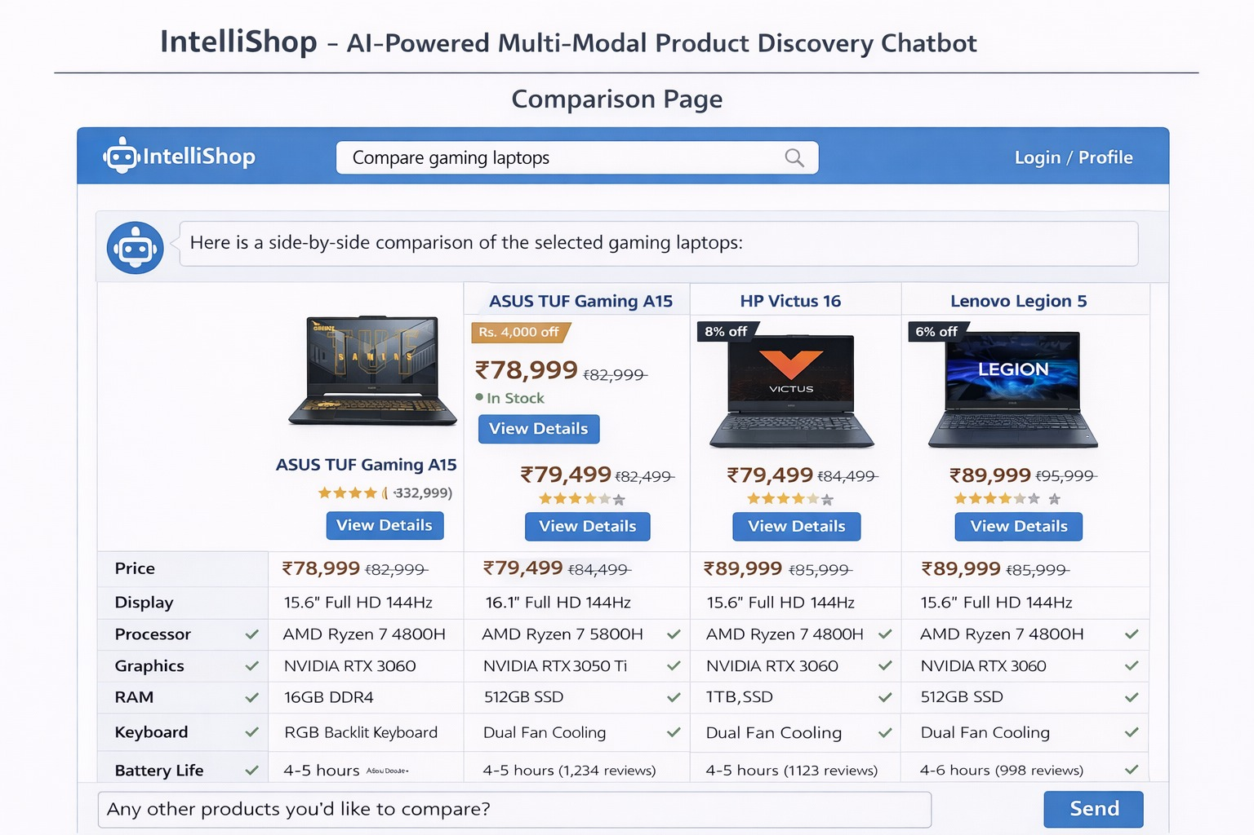

* **User Dashboard**

**Figure:**

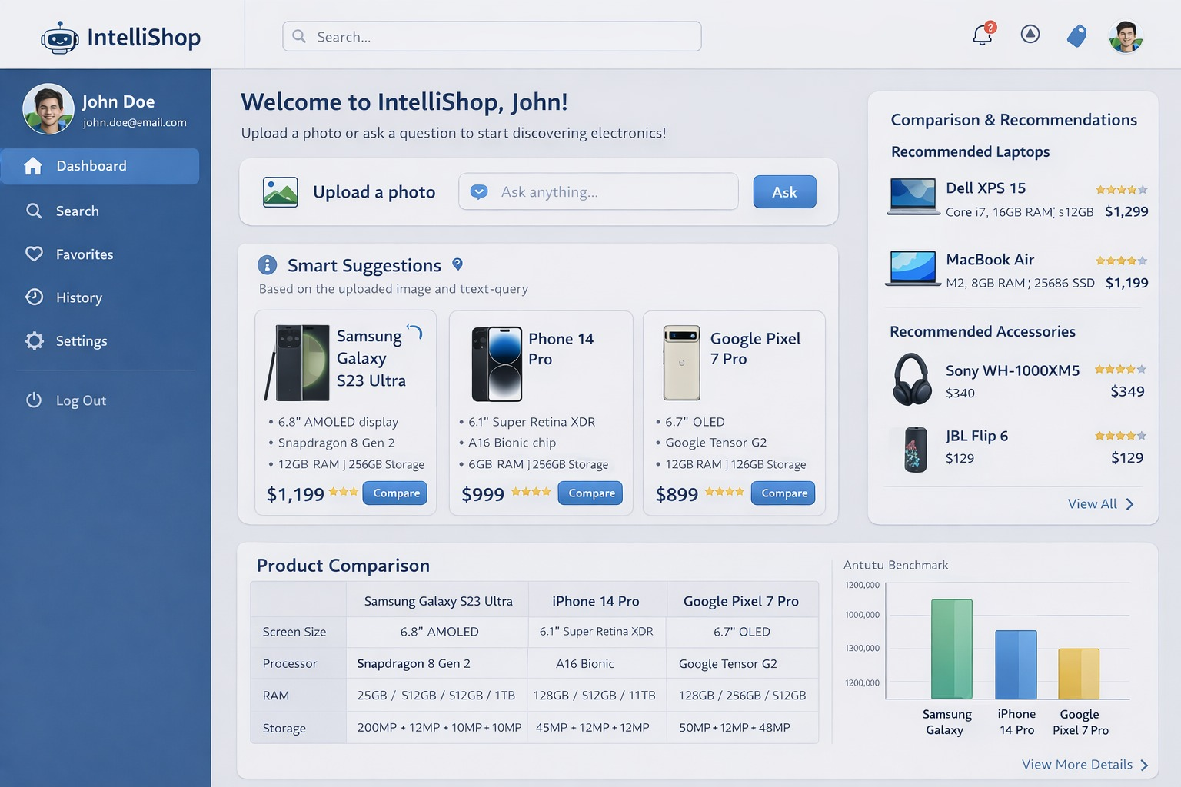

* **Build Your Setup Screen**

**Figure:**

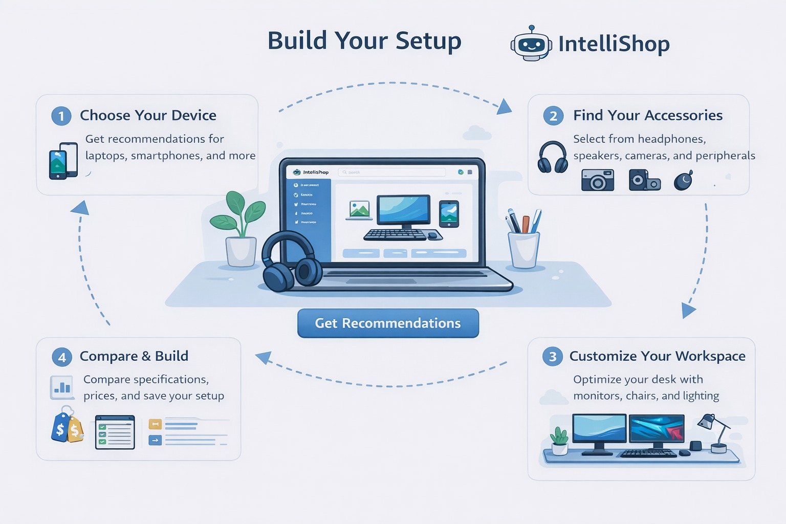

### **UI Controls**

* Textboxes for search and chat
* Buttons for actions (Compare, Save, Buy)
* Dropdowns for filters
* Image upload control for product recognition

### **Input Constraints**

* Required field validation
* Budget range limits
* Supported image formats (JPG, PNG)

**Figure:**

